Time: 60 minutes
Directions: Each of the 30 multiple-choice questions is followed by five possible answer choices. Choices A through D will provide answers, while Choice E is for none of the above. Scoring will be as follows: 5 points for a correct answer, 0 for a wrong answer, and 1 for a blank answer (for a maximum possible score of 150). Figures are not necessarily drawn to scale. Do not choose incomplete answers: if a question has more than one solution, do not select a choice that only provides one of the solutions!
Calculators are not permitted.

- Write the algebraic expression for “the sum of x and 4 cubed divided by 6, minus 7.”
A)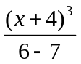 B)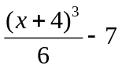 C)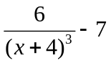 D) 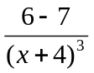 E) NOTA
- Evaluate the following: 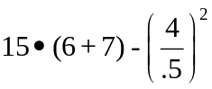
A) 131 B) 179 C) 181 D) 194.36 E) NOTA

- Venom is trying to poison Spiderman. He needs a mixture of exactly 75% poison for Spiderman to die. Right now, Venom has a gallon of pure water. How much pure poison does he need to add?
A) .25 gallons B) .75 gallons C) 1 gallon D) 3 gallons E) NOTA

- The factorial of an integer x, denoted x!, is the product of an integer and all the integers less than it but greater than 0 (For example, 5! = 5 x 4 x 3 x 2 x 1 = 120). Solve the following: 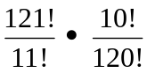
A) 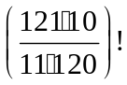 B) 11 C) Does Not Exist D) E) NOTA

- Spiderman is awesome. He also slings web in a linear pattern. He starts on a building at point (5, -6), and shoots his web up to the point (11, 2). How long was his web?
A)  B) 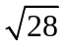 C)10 D) 16 E) NOTA

- Convert the repeating decimal .3636363636… to a simplified fraction.
A) B)  C)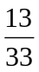 D) 4 E) NOTA

- Factor the following: 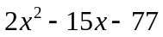
A)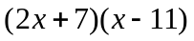 B)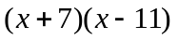 C) 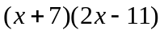 D) Not factorable E) NOTA

- Spiderman is hardcore. He also knows every multiple of 9. Ever. Which of these would Spiderman tell you is definitely NOT a multiple of 9?
A) 14863212 B) 76266783 C) 78835437 D) 645360876 E) NOTA

- Spiderman likes chickens. Two trains are heading toward each other, both at a rate of 100 mph. The Green Goblin stole one of Spiderman’s prized chickens, and cut off its head. The chicken, beginning from Train A, started running towards Train B, going at a rate of 150 mph. Once the chicken reaches the other train it immediately turns around and runs toward Train A. Assuming the trains are starting off 500 miles apart, how many miles does the headless chicken run before the trains collide?
A) 175 B)275 C) 375 D) E) NOTA

- Eight nerds, Gaku, Carolyn, Xixi, Logan, Roland, Kavita, Brandon, and Shuyao, are waiting in line to see Spiderman 7. Xixi is on Logan’s limited profile on Myspace, they can’t stand next to each other. Roland hit Kavita in the face with a Chinese yo-yo, she can’t stand next to him. Shuyao and Carolyn are bonded by their love for anime so they must stand next to each other. Logan and Brandon are Siamese twins and cannot be separated. Gaku has so many trophies that he needs Roland to help him carry them so they stand next to each other. Which of the following is a possible combination for the line?
A) Roland, Gaku, Shuyao, Kavita, Brandon, Logan, Carolyn, Xixi
B) Shuyao, Carolyn, Kavita, Roland, Gaku, Xixi, Brandon, Logan
C) Kavita, Gaku, Roland, Xixi, Shuyao, Carolyn, Logan, Brandon
D) Logan, Gaku, Roland, Kavita, Xixi, Brandon, Carolyn, Shuyao
E) NOTA

- Peter Parker has two favorite classes: Calculus and Chemistry. The students in his college don’t share the same enthusiasm for both of these classes, but if you are in the college you must take at least one of these 2 courses. We know that 18 students that take Calculus. There are 6 students that are only in Chemistry. If we know that there is one student that takes only calculus, then how many students are in Peter’s college?
A) 23 B) 24 C) 25 D) 36 E) NOTA

- Spiderman received a coupon from a GIANT chicken (he likes those). It offered him a 30% discount on a microscope. Spiderman went to the store and it regularly costs $50. How much does Spiderman pay for the microscope with the coupon and a sales tax of 7%?
A) $ 37.45 B) $ 53.50 C) $ 65.00 D) $ 69.55 E) NOTA

- Solve the following system of equations, then find x + y
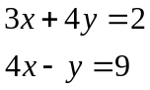
A) 3 B) 1 C) -3 D) no solutions E) NOTA

- Spiderman is directly dependent on the amount of web in his system. When he has 19 gallons of webbing in his system, he works at 76% of his maximum. How many gallons does he have in his system when he is working at 24% of his maximum?
A) 3.6 gallons B) 4.6 gallons C) 5 gallons D) 6 gallons E) NOTA

- Spiderman has 240 chickens. What is the prime factorization of 240?
A) 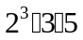 B)  C)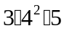 D) E) NOTA

- If the symbol  is defined by the following: 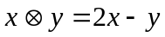, then what is the numerical value of the following: 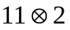
A) 20 B) 24 C)30 D)40 E) NOTA
- Spiderman’s alter persona, Peter Parker, has a set of statistical data. It is as follows: 8, 23, 2, 17, 20, 12, 40, 47, 12, and 19. If the median is equal to y. What is 2y?
A) 18 B) 34 C) 36 D) 38 E) NOTA

- Find all values of x: 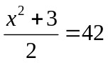
A) 3, -3 B) 9, -9 C) 81, -81 D) No Real solutions E)NOTA

- S, P, I, D, E and R are collinear (lie on the same line). D is the midpoint of S and P. I is the midpoint of S and D. E is the midpoint of S and R. S is the midpoint of E and I. And R is the starting point. What is the order of points?
A) REDIPS B) REIDSP C) SPIDER D) RESIDP E) NOTA

- Consider the sequence 2, 5, 11, 23, … What is the sum of the next two terms?
A) 47 B) 95 C)123 D)142 E)NOTA

- The Green Goblin has stolen a priceless diamond from Tiffany’s and is flying away from Tiffany’s at a speed given by the equation 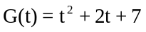, where t is in seconds and G is in ft/sec. What is the Green Goblin’s speed, in ft/sec, after 2 seconds?
A) 15 B) 18 C) 19 D)22 E)NOTA

- 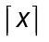is the smallest integer greater than or equal to x. What is 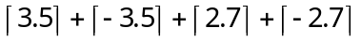?
A) -2 B)0 C)2 D)7 + 2e E)NOTA

- If 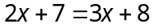, then what does 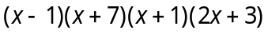 equal?
A) 0 B) 14 C)23 D)56 E)NOTA

- Peter Parker is a very busy kid, so he hasn’t been able to go to Quantum Physics class very often. His grades have been slipping! He needs at least a “C” ( at least 70%) to continue his scholarship. The grades on all his tests have been 67%, 94%, 90%, 83%, and 23% (this was after his fight with Venom in Spiderman 3). What is the minimum grade Peter needs to get on his last test in Physics to keep his scholarship?
A) 0% B)43% C)63% D)100% E)NOTA

- If Spiderman is at point (5, 7 ) and Mary-Jane is at point (-23, 4 ), then at what point will they meet if Spiderman and Mary-Jane are traveling at the same rate of speed along the line between them?
A) ( -9 , 6 ) B) ( -9 , 5.5 ) C) ( -8 , 6 ) D ( -8 , 5.5 ) E) NOTA

- Peter Parker is trying to earn some money because he wants to buy Mary-Jane a present. He decides to start up a lawn mowing business, where he charges 30 dollars an hour. Peter can mow 1500 sq. feet in 12 minutes, how much money will Peter get paid to mow 10,500 sq. feet?
A) 7 B) 30 C) 36 D) 42 E) NOTA

- Convert the line to slope-intercept form: 7x +8y – 11 = 0.
A) 7x + 8y = 11 B) 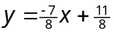 C) 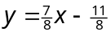 D) 8y = -7x + 11
E) NOTA

- Solve for x in terms of the other variables : 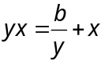
A) 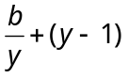 B) 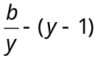 C)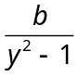 D) 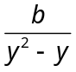 E)NOTA

- Spiderman’s favorite two-digit number is really unique. The sum of the digits times three plus seven is the number itself, and the tens digit times two plus one is the units digit. What is the units digit of Spiderman’s favorite two-digit number?
A) 4 B)5 C)6 D)7 E)NOTA

- Express the following using only positive exponents: 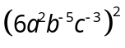
A) 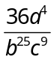 B)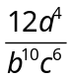 C)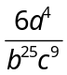 D)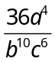 E) NOTA

CHILES MINI MU COMPETITION
ALGEBRA I – SPIDERMAN EATS CHICKEN
ANSWERS

1) B
2) A
3) D
4) B
5) C
6) B
7) A
8) E
9) C
10) C
11) B
12) A
13) B
14) D
15) B

16) A
17) C
18) B
19) D
20) D
21) A
22) C
23) A
24) C
25) B
26) D
27) B
28) D
29) D
30) D

- B.
- A. Order of Operations: 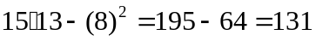
- D. 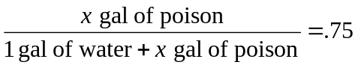→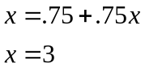
- B. 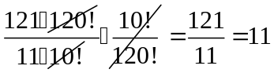
- C. 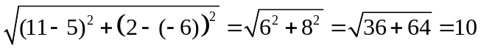

- B. 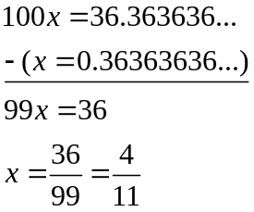

- A.

- E. Add the digits. If that sum is divisible by nine, then the original number is divisible. All of them are. 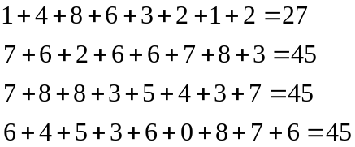

- C. Trains will meet in 2.5 hours. The chicken runs until the trains collide so 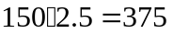

- C. Only solution that follows all the rules.

- B.
1 + 17 + 6 = 24 students
Calculus
Chemistry
17
6
1
- A. 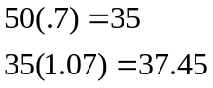
- B. 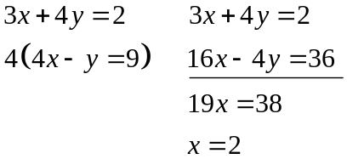 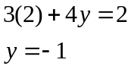 x + y = 2 – 1 = 1
- D. 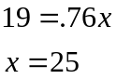→ 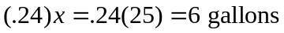
- B. 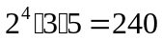
- A.
- C. Median: 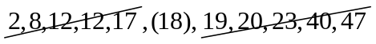
2 (18) = 36
- B. 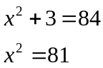→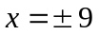
- D.
R
E
S
I
D
P
x
x
x
x
2x

- D. The sequence is defined by 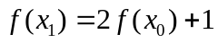
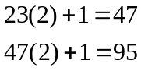 → 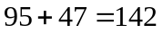
- A. 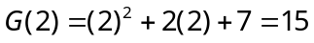
- C.
- A. 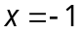→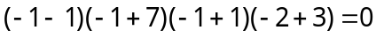
- C. 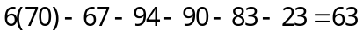
- B. 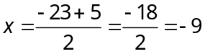 & 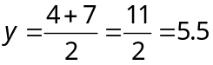→ ( 9, 5.5 )
- D. 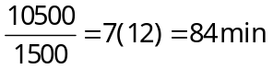→
- B. 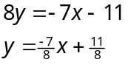
- D. 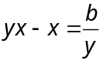→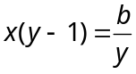→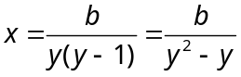
- D. Let x be the tens digit and y be the units digit of Spiderman’s favorite number 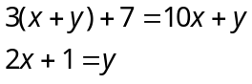→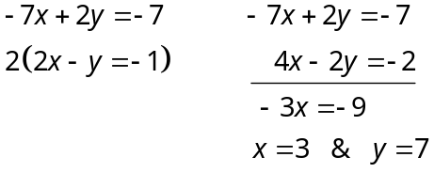
- D. = 

